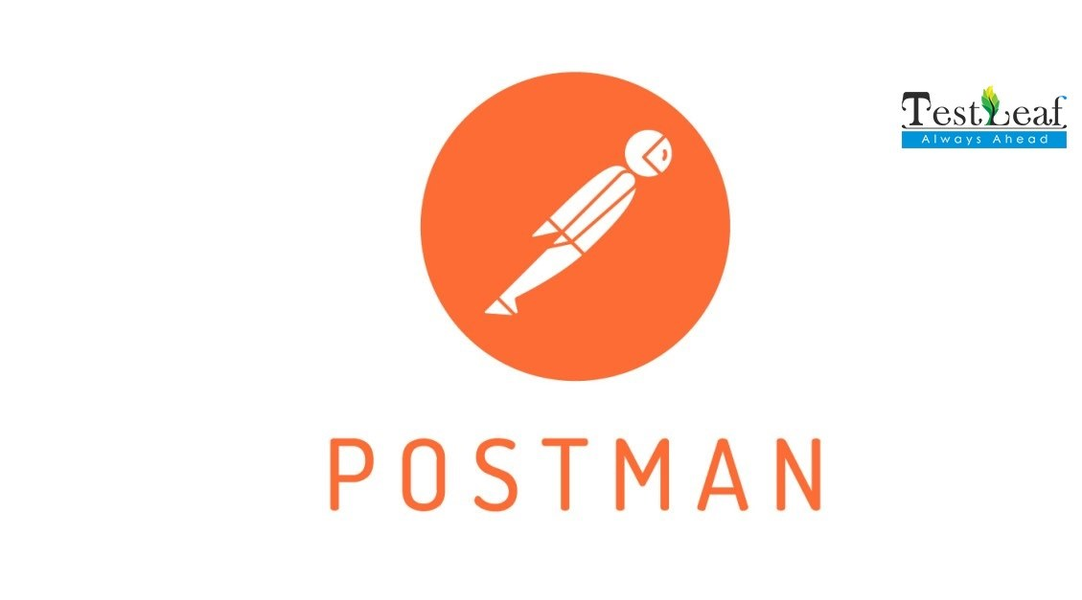

Postman Installation

Postman is a UI based tool used to automate REST API calls, which makes the API automation seamless. Follow the below steps to successfully install Postman in your machine.

* To download, visit the official website of Postman <https://www.postman.com/downloads/>
* Click Windows, Mac or Linux based on your operating systems.
* For downloading the Windows based application, click on the button that has the Windows icon in it. Followed by the choose based on your system binary (32 bit or 64 bit)
* Upon completing the above step an executable file (.exe) would’ve started downloading, you can check the progress of the download. Once it’s downloaded you can install the application by double clicking on it.
* Once the Postman app is launched, create an account. It’ll help you to save your work. Click on the Create Account button, which will redirect you to the Postman’s create account webpage.
* Fill in the above fields to create your account
* Time to create your profile
* Click on Continue Without a Team
* Now, click on the Settings icon in the right side of the window and click on Settings, followed by click on Update and click on Update.
* Make sure the Postman is up-to-date.
* Click on Workspaces and then followed by My Workspace
* Once Workspace is created then you’ve to create a Collection (like a project), here you can have a group of API Requests and they can be arranged in folders
* To create a new Collection, click on New, followed by Collection
* Create a name for your Collection and click enter and close the window of the collection